DOCKER TASK 03
- Create a image from running container.
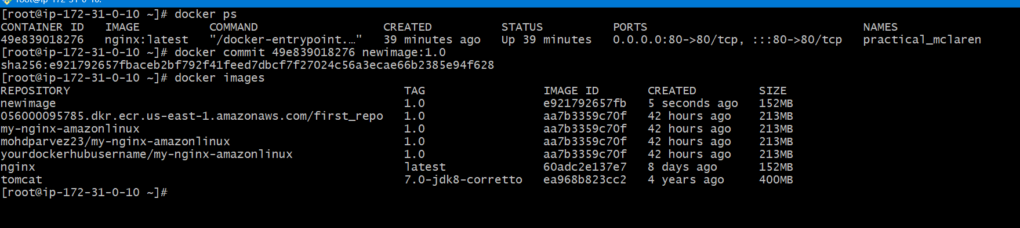
#docker commit <container-id-or-name> myrepo/myimage:from-running

Copy image from local machine to docker server and load the image.
- Create the tar fille and save the image in the tar file
#docker save -o <myimage_latest>.tar <myimage:latest>
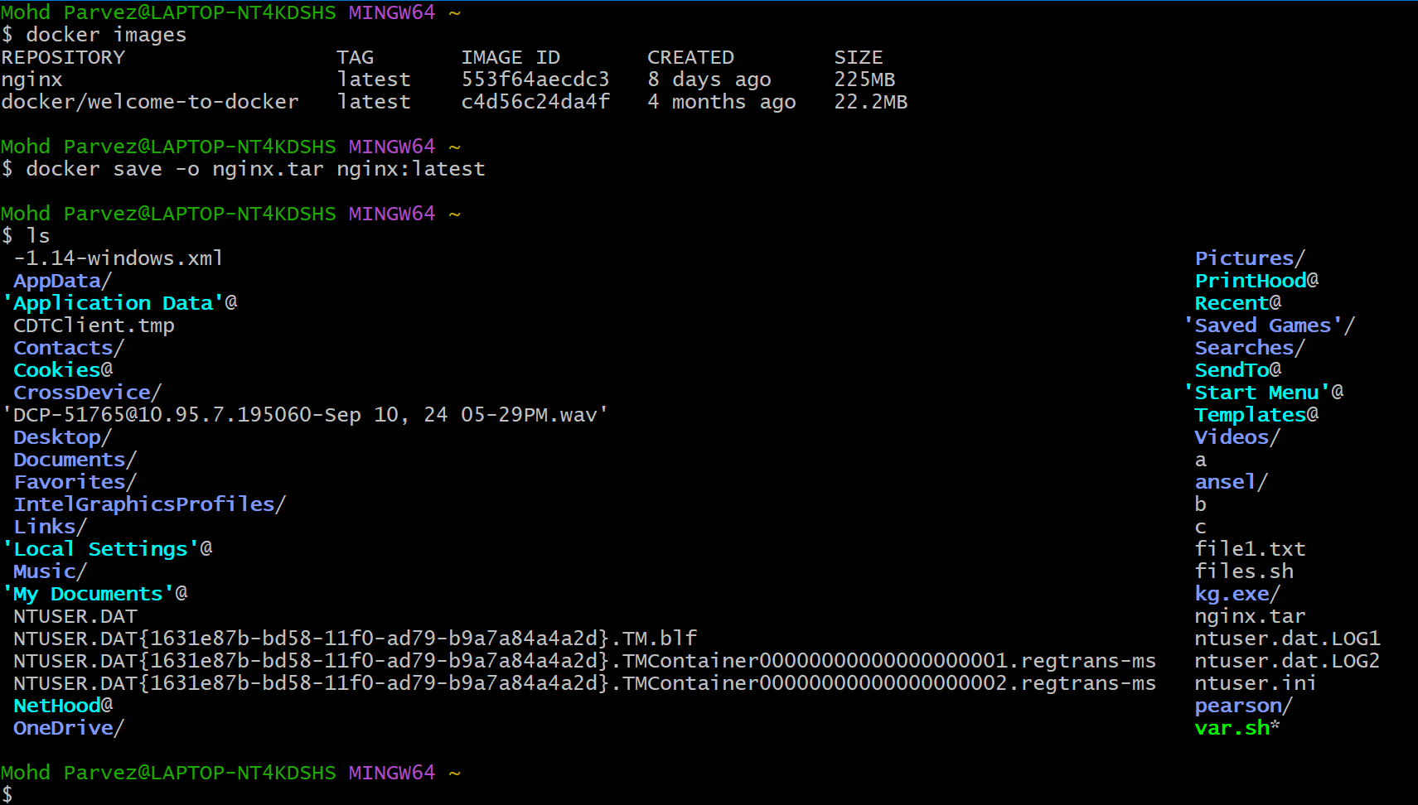

Use command
#scp -i /path/to/pemkey filename.tar ec2-user@<ip_adress>:/tmp
This will copy the tar file created from the local to the server
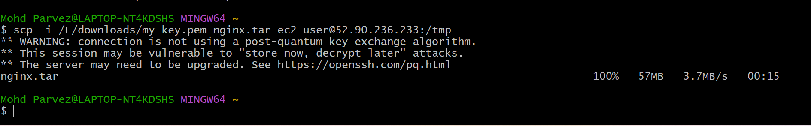
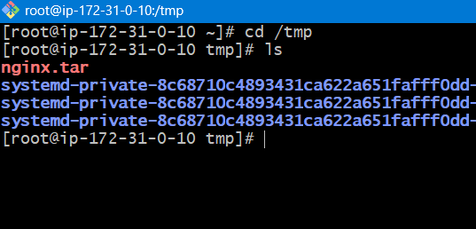
To load the image use command
# docker load -i /tmp/nginx.tar
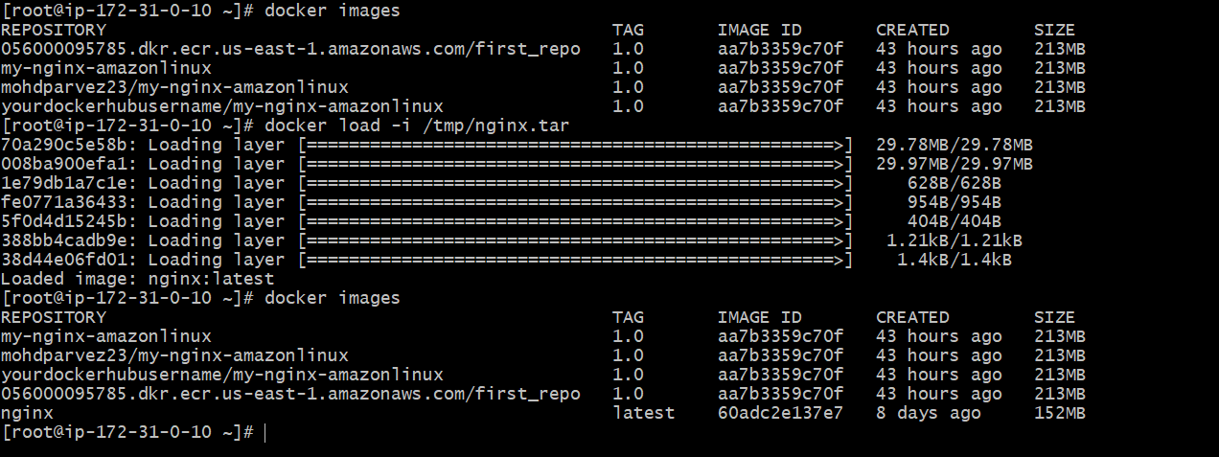

Create Docker image using alpine and customize with tomcat.
Create a dockerfile
#vi Dockerfile
insert
FROM alpine:latest
MAINTAINER Techie_Horizon
RUN mkdir /usr/local/tomcat/
WORKDIR /usr/local/tomcat
RUN apk --no-cache add curl && \
apk add --update curl && \
curl -O https://dlcdn.apache.org/tomcat/tomcat-11/v11.0.14/bin/apache-tomcat-11.0.14.tar.gz
RUN tar -xvf apache*.tar.gz
RUN mv apache-tomcat-11.0.14/* /usr/local/tomcat/.
RUN rm -rf apache-*
COPY sample.war /usr/local/tomcat/webapps
RUN apk update && apk add openjdk17
WORKDIR /usr/local/tomcat
EXPOSE 8080
CMD ["/usr/local/tomcat/bin/catalina.sh", "run"]
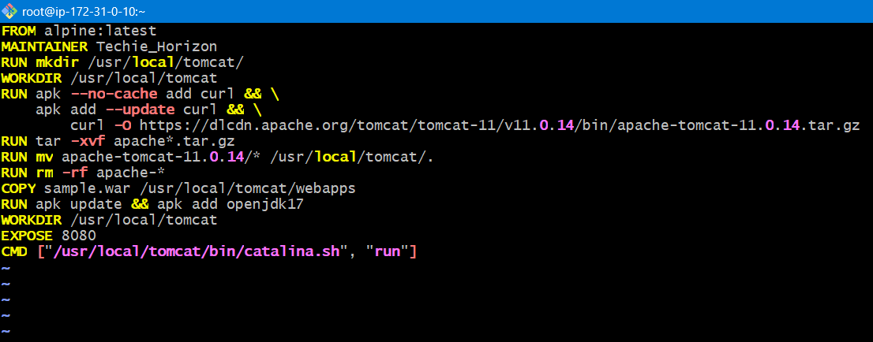
#docker buildx build -f Dockerfile .
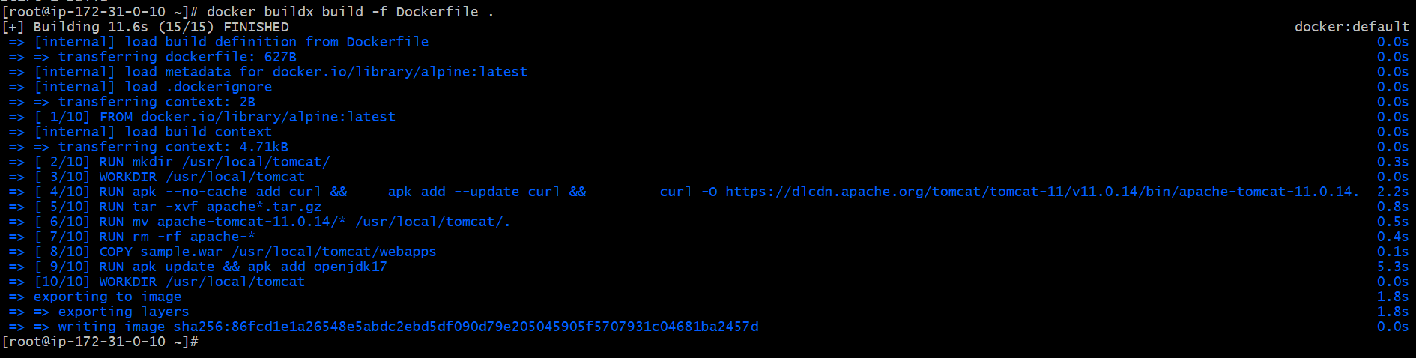
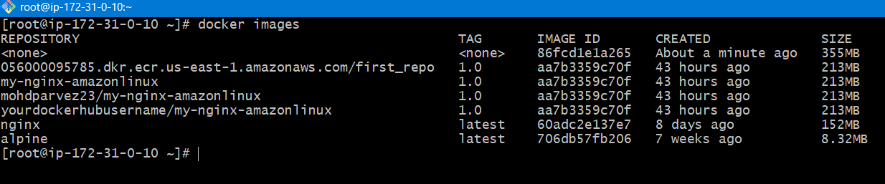

Create single stage and multi stage docker file using this source code: https://github.com/betawins/multi-stage-example.git
#vi Dokerfile.single
FROM eclipse-temurin:8-jdk
RUN apt-get update && apt-get install -y bash && rm -rf /var/lib/apt/lists/*
WORKDIR /app
COPY . .
RUN chmod +x mvnw
RUN ./mvnw clean package -DskipTests
EXPOSE 8080
CMD ["java", "-jar", "target/app.jar"]

clone the repo to the machine
#git clone https://github.com/betawins/multi-stage-example.git

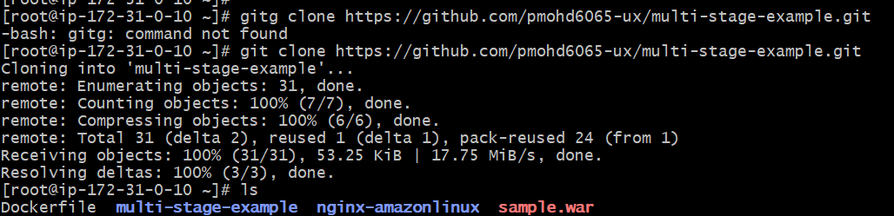

now got to the directory #cd multi-stage-example

give permission #chmod +x mvnw
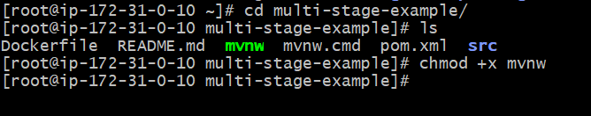

now build the image
#docker buildx build -f Dockerfile.single -t my_image:1.0 .

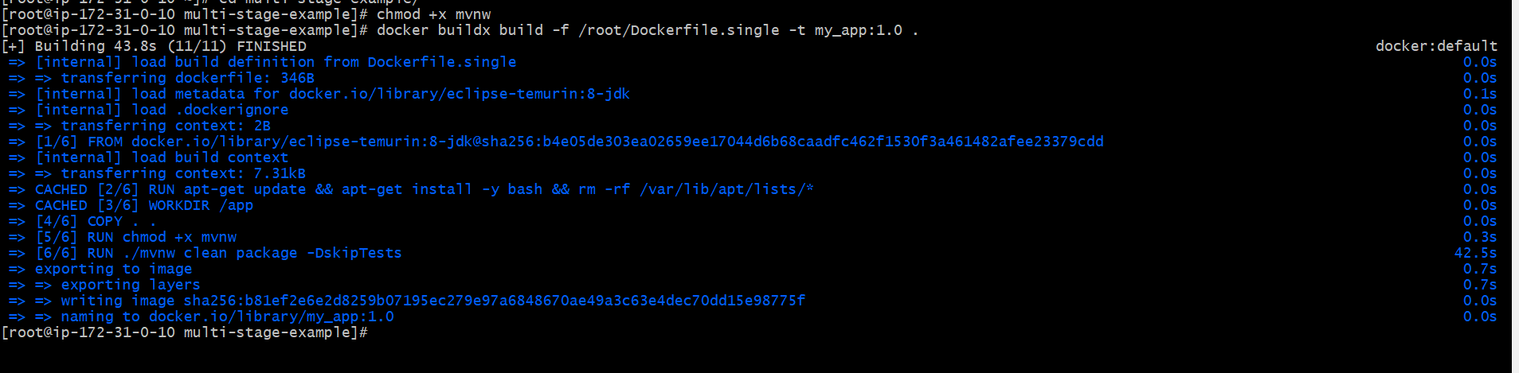
Check the images #docker images
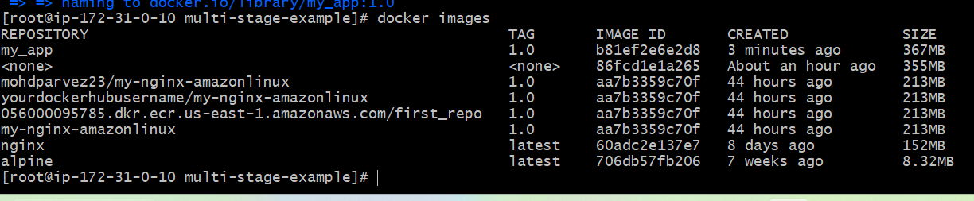

MULTISTAGE DOCKER FILE

create the docker file for multistage to build and run the image
# vi Dockerfile.multistage
# ---------- Build Stage ---------
FROM eclipse-temurin:8-jdk AS builder
RUN apt-get update && apt-get install -y bash && rm -rf /var/lib/apt/lists/*
WORKDIR /app
COPY . .
RUN chmod +x mvnw
RUN ./mvnw clean package -DskipTests

# ---------- Run Stage (small) ---------
FROM eclipse-temurin:8-jre-alpine
WORKDIR /app
COPY --from=builder /app/target/*.jar /app/app.jar
EXPOSE 8080
CMD ["java", "-jar", "/app/app.jar"]

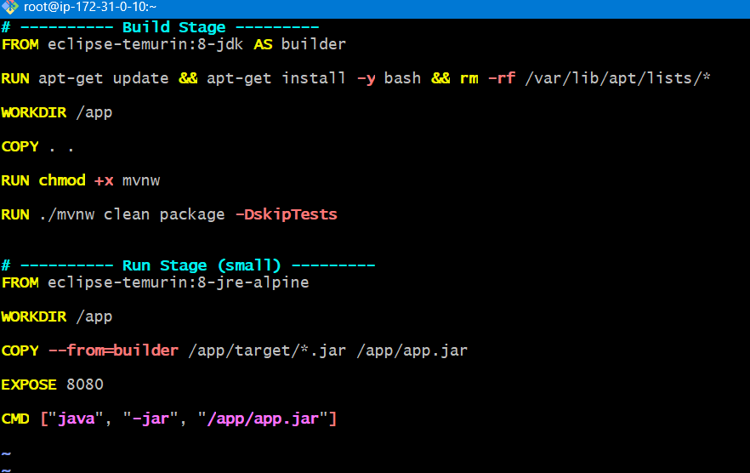
Build the image using docker file
# docker buildx build -f /root/Dockerfile.multistage -t my_app:2.0 .
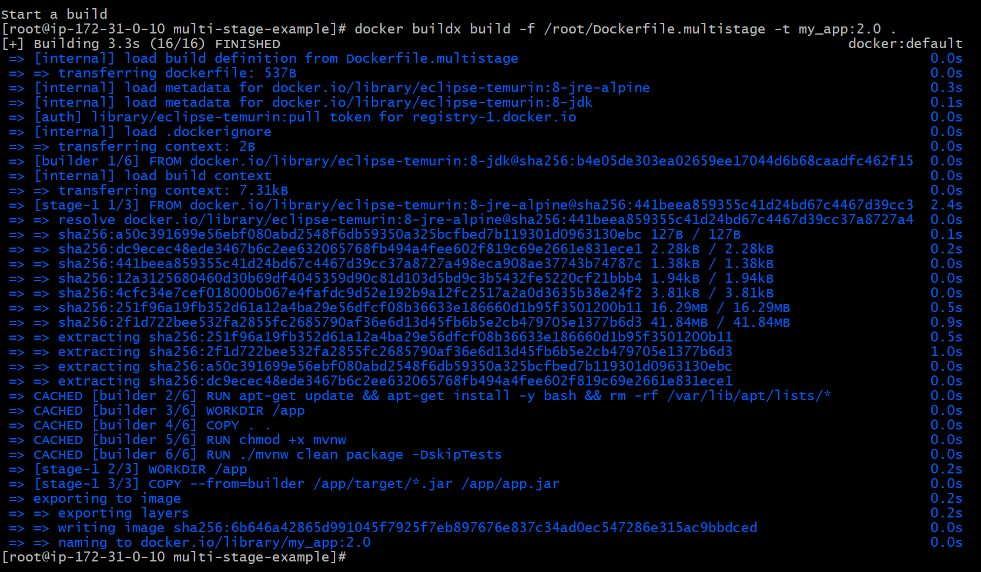
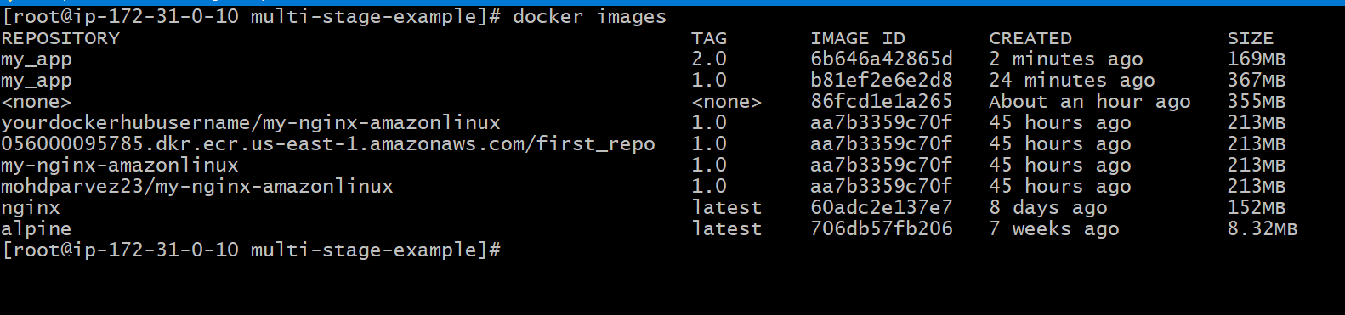
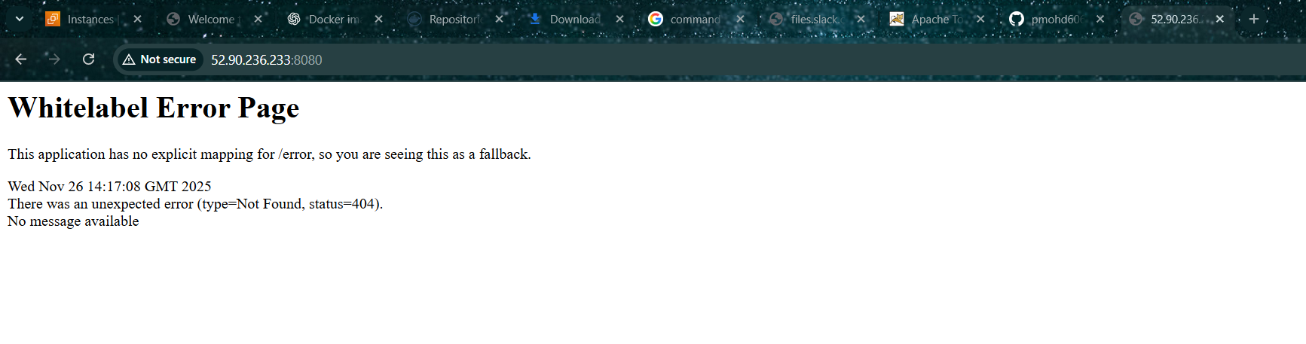

Install docker compose and execute sample application.

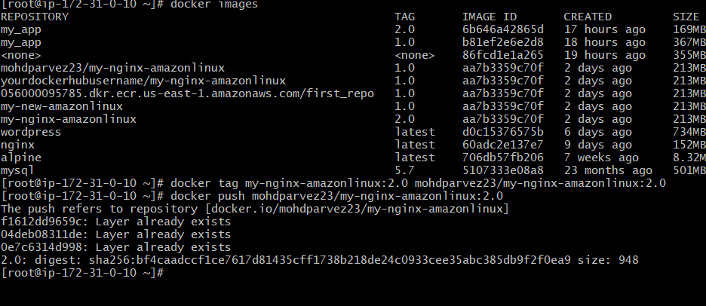
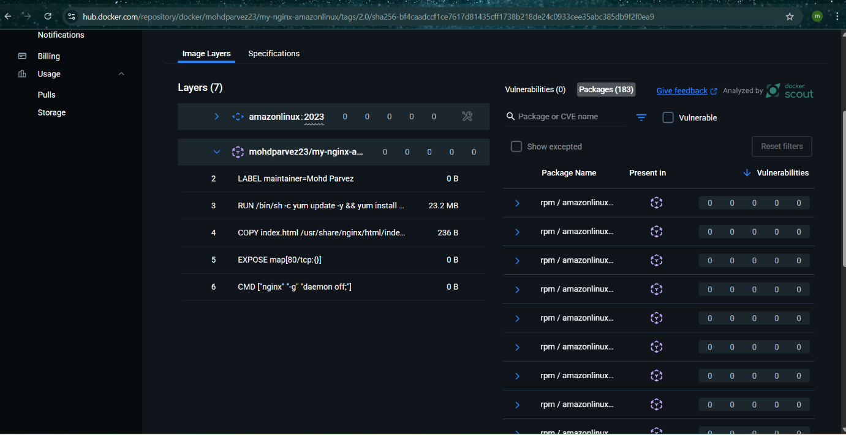

Implement solution to scan images when pushed to docker registry.
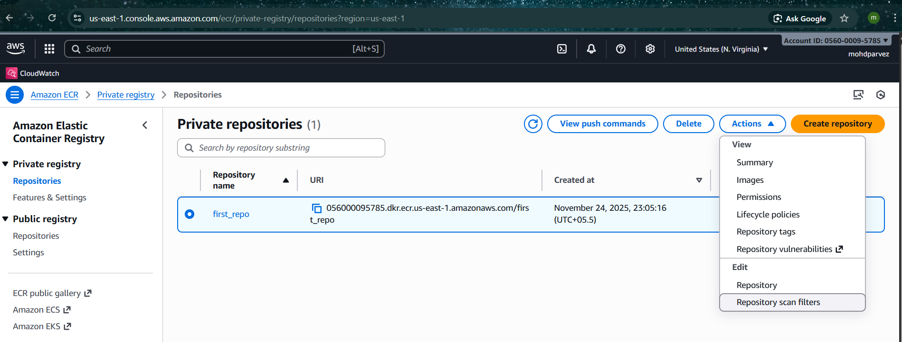

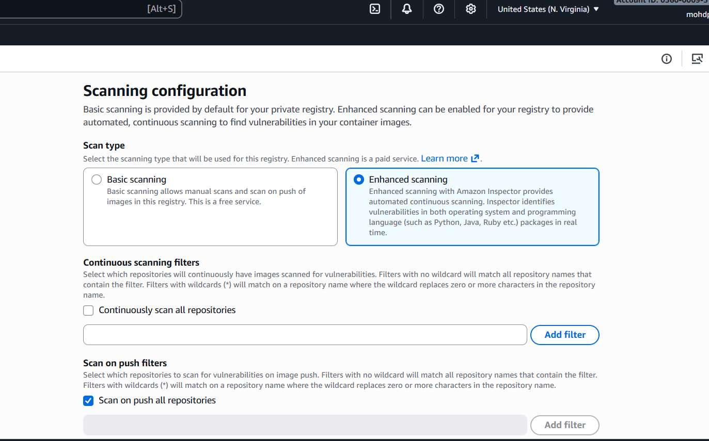
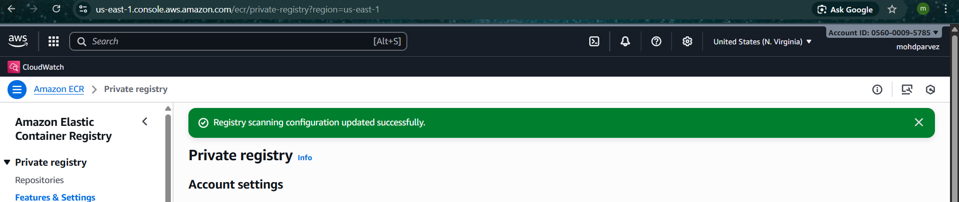

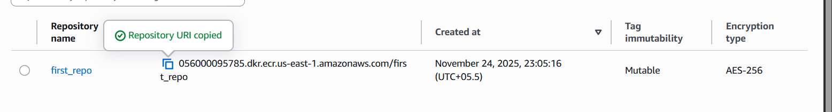
• Retrieve an authentication token and authenticate your Docker client to your registry. Use the AWS CLI:
#aws ecr get-login-password --region us-east-1 | docker login --username AWS --password-stdin 056000095785.dkr.ecr.us-east-1.amazonaws.com
Note: If you receive an error using the AWS CLI, make sure that you have the latest version of the AWS CLI and Docker installed.
• Build your Docker image using the following command. For information on building a Docker file from scratch see the instructions here . You can skip this step if your image is already built:
#docker build -t first_repo .
• After the build completes, tag your image so you can push the image to this repository:
#docker tag first_repo:latest 056000095785.dkr.ecr.us-east1.amazonaws.com/first_repo:latest
• Run the following command to push this image to your newly created AWS repository:
#docker push 056000095785.dkr.ecr.us-east-1.amazonaws.com/first_repo:latest

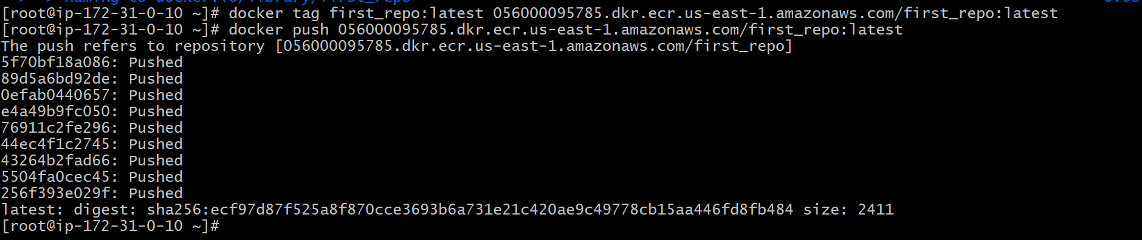
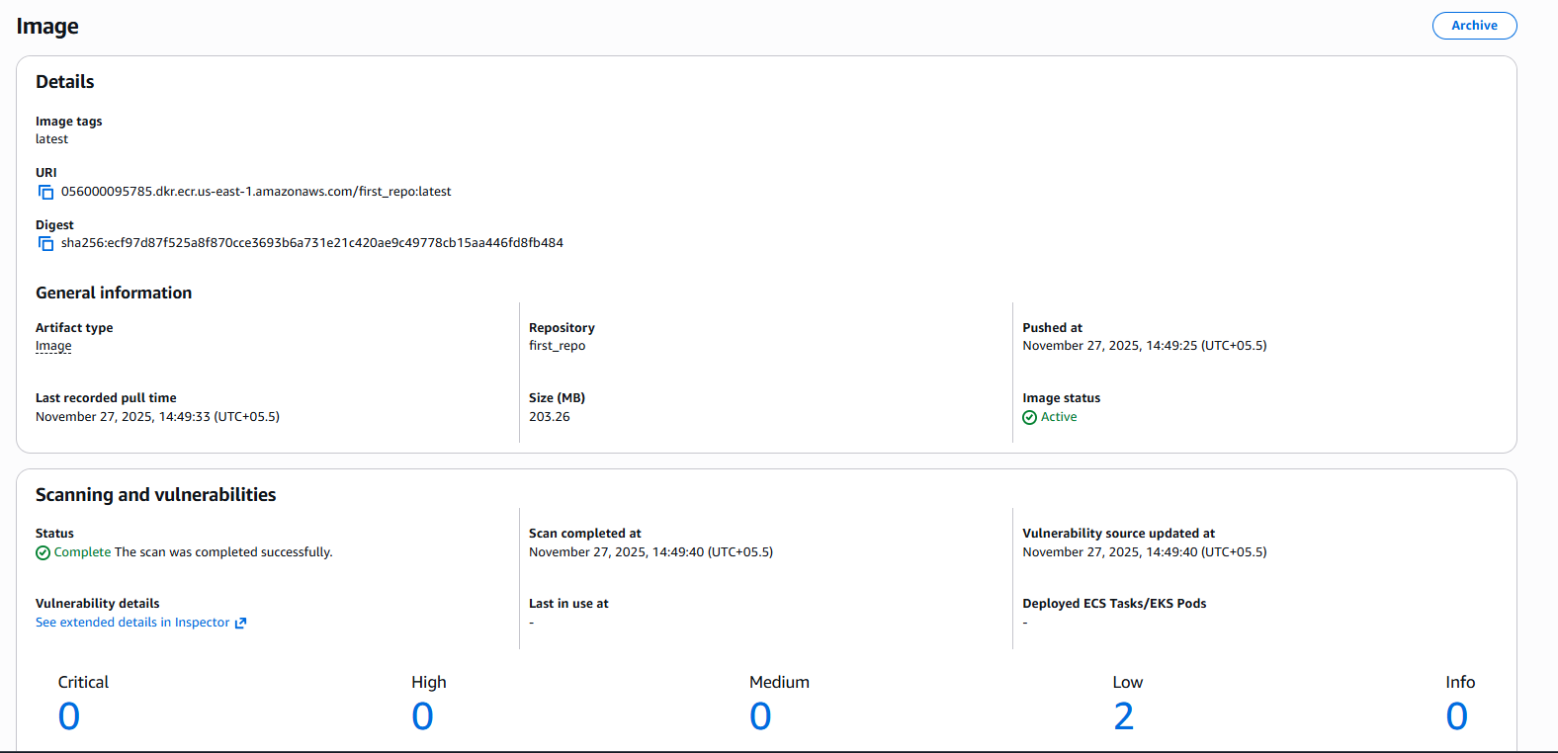
Useful commands & scripts
Build & push to ECR (example)
# login (use aws cli v2)
aws ecr get-login-password --region us-east-1 | docker login --username AWS --password-stdin <aws_account_id>.dkr.ecr.us-east-1.amazonaws.com
# tag
docker tag multi-example:multi <aws_account_id>.dkr.ecr.us-east-1.amazonaws.com/my-ecr-repo:latest
# push
docker push <aws_account_id>.dkr.ecr.us-east-1.amazonaws.com/my-ecr-repo:latest

Create a Jenkins pipeline to create a docker image and push the image to Docker hub.
#docker run -d \ --name jenkins \ -p 8080:8080 \ -v /var/run/docker.sock:/var/run/docker.sock \ -v $(which docker):/usr/bin/docker \ jenkins/jenkins:lts

pipeline {
agent any

environment {
DOCKER_IMAGE = "mohdparvez23/myapp:latest" // replace with your Docker Hub repo
}

stages {
stage('Check Docker') {
steps {
sh 'which docker || true'
sh 'docker --version || true'
}
}
stage('Build Docker Image') {
steps {
sh 'docker build -t $DOCKER_IMAGE .'
}
}

stage('Login to Docker Hub') {
steps {
withCredentials([
usernamePassword(
credentialsId: 'docker-hub-creds',
usernameVariable: 'DOCKER_USER',
passwordVariable: 'DOCKER_PASS'
)
]) {
sh 'echo $DOCKER_PASS | docker login -u $DOCKER_USER --password-stdin'
}
}
}

stage('Push Docker Image') {
steps {
sh 'docker push $DOCKER_IMAGE'
}
}
}
}
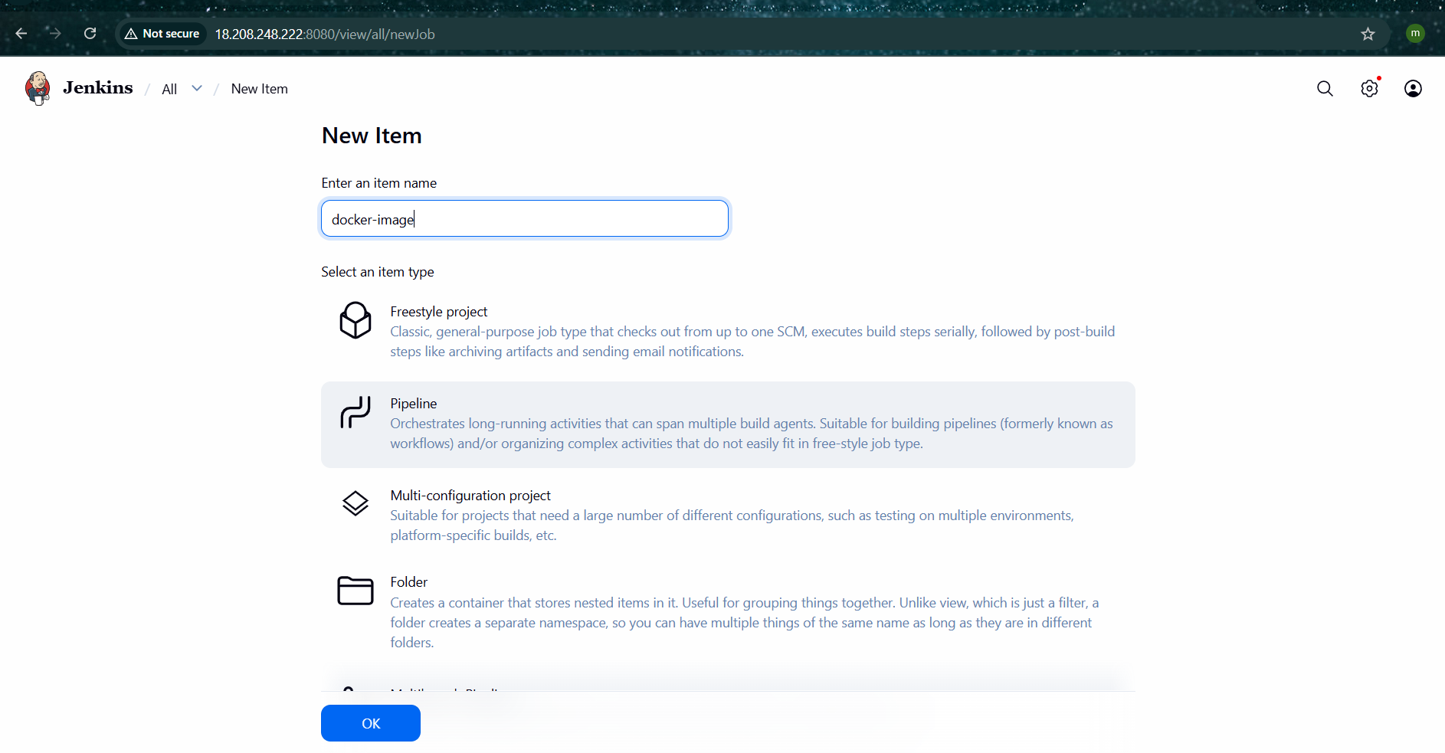
/var/jenkins_home/workspace/docker-image
